BAHRIA UNIVERSITY KARACHI CAMPUS
DEPARTMENT OF COMPUTER ENGINEERING



BAKERY POS INTERFACE
CSC 210 Object Oriented Programming
Adeel Khan 02-132242-020

- Acknowledge
I would like to express my sincere gratitude to Miss USRA SAMI for guiding me throughout this project. I also thank my friends and peers for their support and encouragement. Their valuable suggestions and guidance helped me complete this Bakery POS Interface project successfully.

- Abstract
This project presents a Bakery POS (Point of Sale) Interface developed using Java Swing. The system allows a user to select bakery items, view daily specials, add them to a cart, calculate the total bill, and checkout. Additionally, all orders are stored in an MS Access database for record-keeping. The project demonstrates GUI design, event handling, OOP concepts, and database connectivity in a practical desktop application

- List of context
- Project Title: Bakery POS Interface
- Programming Language: Java
- IDE Used: NetBeans
- GUI Library: Java Swing
- Database: MS Access
- JDBC Driver: UCanAccess
- Core Concepts: OOP, Event Handling, GUI Design, Database Connectivity

- List of figure
- GUI Layout of Bakery POS Interface
- Menu Panel with ComboBoxes
- Special Items Panel
- Cart Panel with JTextArea and JScrollPane
- Checkout Button Functionality
- Database Table in MS Access
- Introduction
A Bakery POS System is a desktop application that simulates a bakery billing counter. It enables users to select items from various categories, view daily specials, calculate total bills, and store order information in a database. This system improves order management, reduces manual calculation errors, and demonstrates the practical application of Java Swing and OOP concepts.

- Literature Review
Traditional bakery billing is mostly manual, using pen-and-paper or simple calculators. Manual systems are prone to errors and lack a digital record. Modern POS systems digitize this process, providing efficiency and data storage. This project focuses on developing a simple desktop-based POS system that introduces GUI design, event handling, and database connectivity using Java and MS Access.

- Problem and solution
Problem:
- Manual billing is time-consuming and prone to errors.
- Difficult to track daily orders or maintain a record.
Solution:
- Develop a GUI-based Bakery POS Interface using Java Swing.
- Users can select items, add to cart, calculate total, and checkout.
- Orders are automatically stored in an MS Access database for record-keeping
- Workflow
- User opens the Bakery POS Interface.
- User selects items from Menu Panel or Today’s Specials Panel.
- Clicks “Add to Cart” to add items to the cart.
- Cart updates with item details and total amount.
- User clicks “Checkout” to finalize the order.
- Order details are saved into MS Access database.
- System resets for the next customer

- Methodology
- Programming Language: Java
- GUI: Swing (JFrame Form, JPanel, JComboBox, JTextArea, JScrollPane, JButton)
- OOP Concepts: Encapsulation, Classes, Objects, Methods
- Event Handling: ActionListener for buttons
- Database: MS Access connected via UCanAccess JDBC driver
- Steps:
- Design GUI using NetBeans JFrame Form.
- Add menu and special item ComboBoxes.
- Add Add to Cart, Clear, and Checkout buttons.
- Append selected items to JTextArea cart.
- Calculate total bill dynamically.
- On Checkout, save data to MS Access database.

- Output(screen shots with details )
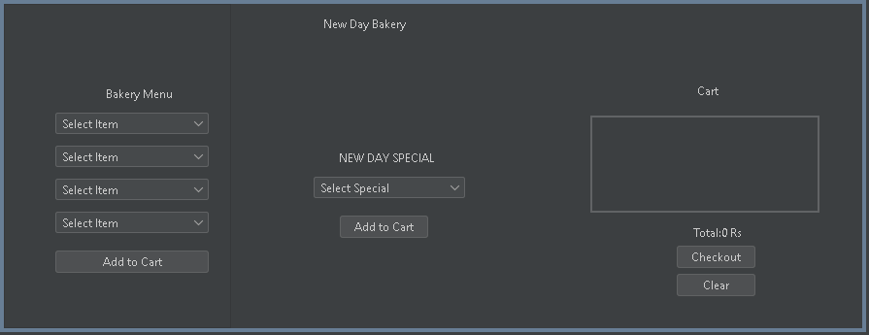
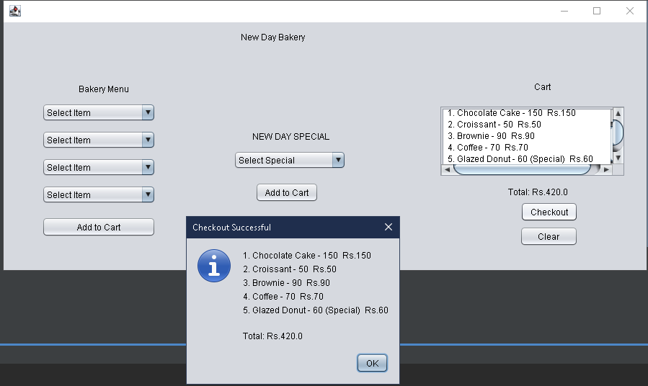

- Conclusion
The Bkery POS Interface project successfully demonstrates a desktop-based billing system with GUI, event handling, and database connectivity. It reduces manual errors, maintains records, and provides a simple and intuitive interface for bakery billing. The project effectively applies Java OOP concepts in a practical scenario

- Future work
- Add quantity selection for items.
- Include images of bakery items in the GUI.
- Implement user authentication/login.
- Generate printable receipts.
- Integrate with a larger database system like MySQL for multi-user support.
- Include real-time reporting and analytics for sales.
- References
- Oracle Java Documentation – https://docs.oracle.com/javase/
- UCanAccess JDBC Documentation – http://ucanaccess.sourceforge.net/site.html
- Java Swing Tutorials – https://www.javatpoint.com/java-swing
- MS Access Documentation – https://support.microsoft.com/access
- NetBeans Official Documentation – https://netbeans.apache.org

GUIDELINES FOR PROJECT REPORT
- The project report should be hard bound
- The front cover of the report should be in printed form along-with the university logo (new).
- Only right side of pages of the report should be printed; the left side should be left blank
- The font used should be Times New Roman, 12 points plain, with one-and-a-half (1.5) spacing between two consecutive lines
- For sub-headings, increase one point and for main headings increase one more point.
- All the pages should be properly numbered.

